COMPACT TUFT
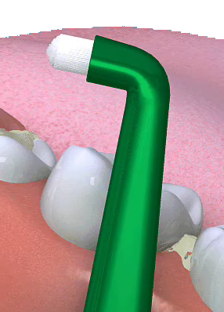

Q What is a compact tuft?

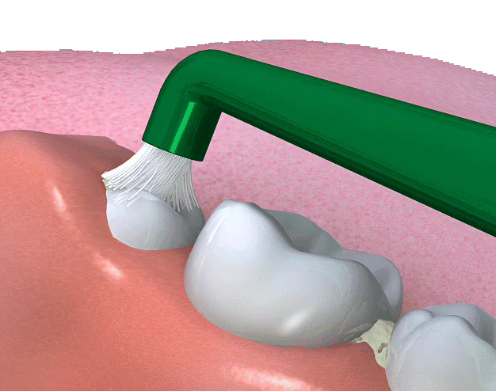
A It is a single tufted toothbrush that that has short and extra soft filaments that are designed to clean in and around difficult to clean areas such as implants and newly erupted teeth.

Q Do I use this instead of my normal toothbrush?

A No, it is designed to be used in conjunction with your normal oral hygiene regime. It just helps you access those areas that are difficult to clean effectively with a standard toothbrush.

Q How do I use it?

A The filaments of the brush are designed to be splayed under pressure to achieve gentle but effective plaque removal.

An effective cleaning technique for along the gum line can be achieved by gently rotating the splayed filaments a t a 45 degree angle onto the gum margin.

For new and partially erupted teeth, the exposed part of the tooth can be cleaned effectively and comfortably by splaying the filaments onto the tooth surface and agitating the head to disrupt and remover plaque on the tooth surface and form just under the gum.

Q When should I use it.

A At least once a day or as instructed by your dentist or dental hygienist.

